|  |  |
| --- | --- |
| ShopNext Capstone Insights | |
|  |  |
| SKILLOVILLA21-APR-2024DHURUV SINGH |  |

# Summary

1. **Top Categories by Total Price:**
   * Health & Beauty, Watches & Gifts, and Bed & Bath Table emerge as the top three categories by total sales, indicating consumer preferences for personal care, gift items, and home essentials.
   * Insights from these top categories provide valuable information for inventory management, marketing strategies, and product diversification.
2. **Delayed Orders Analysis:**
   * Categories like Bed & Bath Table, Health & Beauty, and Sports & Leisure experience the highest number of delayed orders, highlighting areas for improvement in logistics and supply chain management.
   * Addressing delayed orders is crucial for enhancing customer satisfaction, improving brand reputation, and driving loyalty.
3. **Monthly Comparison of Delayed and On-Time Orders:**
   * March and February witness high order volumes but also significant delays, indicating potential challenges during peak periods.
   * Proactive management and process optimization can help mitigate delays and ensure timely order fulfillment, especially during high-demand months.
4. **Payment Method Analysis:**
   * Credit card transactions dominate, followed by boleto and voucher payments, underscoring the importance of offering diverse payment options to cater to customer preferences.
   * Understanding payment preferences can inform marketing strategies and payment processing optimizations to enhance the overall customer experience.
5. **Product Rating Analysis:**
   * Top-rated products span various categories, indicating diverse customer preferences, while lower-rated products highlight areas for improvement in quality, design, or functionality.
   * Addressing customer feedback and enhancing product offerings can drive customer satisfaction and loyalty.
6. **State-wise Sales Analysis:**
   * São Paulo, Rio de Janeiro, and Minas Gerais lead in sales, emphasizing the importance of understanding regional market dynamics for strategic decision-making.
   * Targeted marketing strategies and infrastructure investments are essential for stimulating economic growth in states with lower sales.
7. **Seasonal Sales Patterns:**
   * Seasonal variations in sales indicate higher demand during summer months and a year-end dip during November and December, reflecting common retail trends.
   * Analyzing seasonal patterns helps businesses anticipate consumer behavior and optimize inventory management and marketing strategies accordingly.
8. **Revenue Analysis:**
   * Significant growth in revenue from 2016 to 2018 suggests a period of rapid expansion and market penetration.
   * While revenue growth may have slowed in recent years, continued focus on innovation, customer satisfaction, and strategic planning can sustain growth and competitiveness in the market.

## **Top Categories by Total Price:**

* Identify and visually represent the top 10 product categories by total sales.

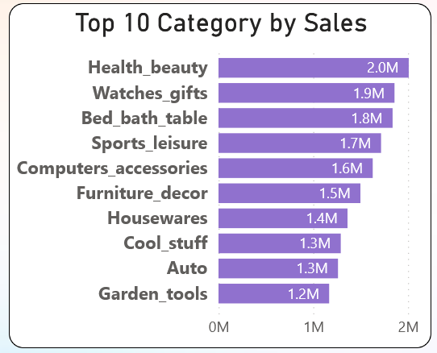

The insights from the top 10 sales categories based on the graph

1. **Health & Beauty (2.0M)**: This category leads in sales, indicating that consumers are interested in products related to personal care, cosmetics, and wellness.
2. **Watches & Gifts (1.9M)**: Watches and gift items are popular, possibly due to special occasions, holidays, or personal preferences.
3. **Bed & Bath Table (1.8M)**: Consumers are investing in home essentials such as bedding, towels, and other items for their bedrooms and bathrooms.
4. **Sports & Leisure (1.7M)**: This category includes sports equipment, outdoor gear, and leisure products, suggesting an active and health-conscious consumer base.
5. **Computers & Accessories (1.6M)**: The demand for computers, peripherals, and tech accessories remains strong, especially in the digital age.
6. **Furniture & Decor (1.5M)**: Consumers are interested in home furnishings, decor, and interior design items.
7. **Housewares (1.4M)**: Housewares encompass kitchenware, appliances, and household essentials, indicating practical purchases.
8. **Cool Stuff (1.3M)**: This intriguing category could include unique gadgets, novelty items, or trendy products.
9. **Auto (1.3M)**: Automotive accessories, parts, or related products are in demand.
10. **Garden Tools (1.2M)**: Consumers are investing in gardening tools and equipment, possibly due to an interest in home gardening or outdoor spaces.

## **Delayed Orders Analysis:**

* 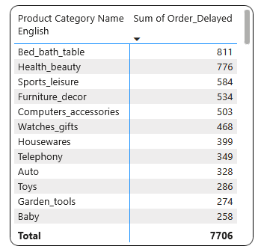Determine the number of delayed orders in each category. An order is considered delayed if the actual delivery date is later than the estimated delivery date.

1. Bed_bath_table, Health_beauty, and Sports_leisure stand out with the highest number of delayed orders, suggesting areas for improvement.
2. Variation exists across categories, indicating differences in demand patterns or operational efficiencies.
3. Opportunities for optimization lie in focusing on categories with high delays, enhancing processes, and improving communication with suppliers.
4. Benchmarking against categories with lower delays can set performance standards.
5. Seasonal trends may influence delays, requiring proactive measures during peak periods.
6. Addressing delayed orders enhances customer satisfaction, strengthens brand reputation, and fosters loyalty.

## **Monthly Comparison of Delayed and On-Time Orders:**

* Create a dynamic visual that compares the number of delayed orders to the number of orders received earlier for each month. Utilize the drillthrough cross-report feature to provide a detailed analysis of late and on-time deliveries.

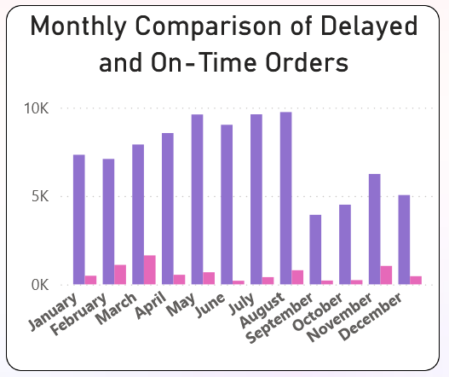

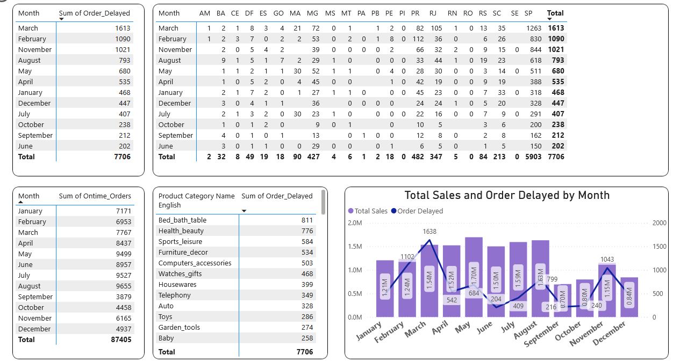

After comparing the number of delayed orders to the number of orders received earlier for each month:

1. **March**: Despite having the highest number of delayed orders (1613), March also saw a substantial number of on-time orders (7767), indicating significant order volume but a notable portion experienced delays.
2. **February**: With 1090 delayed orders and 6953 on-time orders, February exhibits a similar trend of high order volume but a sizable proportion facing delays.
3. **November**: While November experienced 1021 delayed orders, it also had a comparatively high number of on-time orders (6165), suggesting better order fulfillment relative to other months with similar delays.
4. **August, May, April**: These months had a moderate to high number of delayed orders (793, 680, 535, respectively) but also had a large volume of on-time orders, indicating mixed performance in order fulfillment.
5. **June, July, December**: Despite having relatively lower numbers of delayed orders (202, 407, 447, respectively), these months had significant order volumes, indicating efficient order fulfillment processes.
6. **September, October, January**: These months exhibited lower numbers of delayed orders (212, 238, 468, respectively) compared to other months, suggesting better order fulfillment performance or potentially lower order volumes.
7. The distribution of delayed orders is notably influenced by regions such as 'SP', accounting for 1263 instances, 'RJ', with 105, and 'MG', with 72, among others, representing a significant percentage of the total delays.

Insights:

* Months with higher order volumes may experience more delays due to increased demand or operational challenges.
* Efficient order fulfillment processes and proactive management can help reduce delays even during high-demand periods.
* Monitoring and addressing delays in high-volume months like March and February can significantly impact customer satisfaction and retention.
* Understanding seasonal variations and implementing strategies to manage peak periods effectively can optimize order fulfillment and enhance overall operational performance.

## **Payment Method Analysis:**

* Analyze the most frequently used payment methods by customers using a visually appealing representation, such as a pie chart or other suitable visuals.

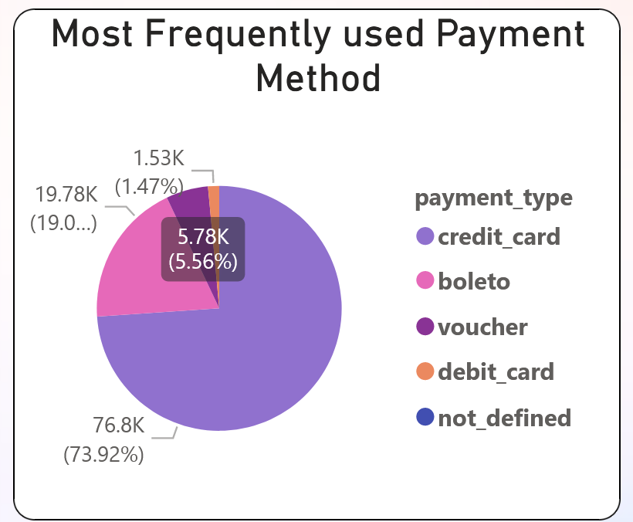

1. **Credit Card**: The most commonly used payment method, with a substantial count of 76,795 orders. This indicates a strong preference for credit card transactions among customers.
2. **Boleto**: With 19,784 orders, boleto emerges as the second most popular payment method. Boleto is commonly used in Brazil and is preferred by customers who do not have access to credit cards or prefer cash-based transactions.
3. **Voucher**: Voucher payments, with 5,775 orders, represent a smaller but still significant portion of transactions. Vouchers may be issued as part of promotions or loyalty programs, encouraging repeat purchases.
4. **Debit Card**: Debit card transactions, totaling 1,529 orders, are less common compared to credit cards and boleto. Customers may prefer credit cards for online purchases due to perceived security or convenience reasons.
5. **Not Defined**: With only 3 orders, the "not defined" category represents a negligible portion of transactions, likely due to incomplete or erroneous payment information.

Insights:

* Credit cards and boleto are the dominant payment methods, indicating the importance of offering diverse payment options to cater to customer preferences.
* Voucher payments, while fewer in number, can still play a significant role in driving sales and fostering customer loyalty.
* Understanding payment preferences can inform marketing strategies and payment processing optimizations to enhance the overall customer experience and increase conversion rates.

## **5. Product Rating Analysis:**

* Determine the top 10 highest-rated products and the bottom 10 lowest-rated products using a bar or column chart.

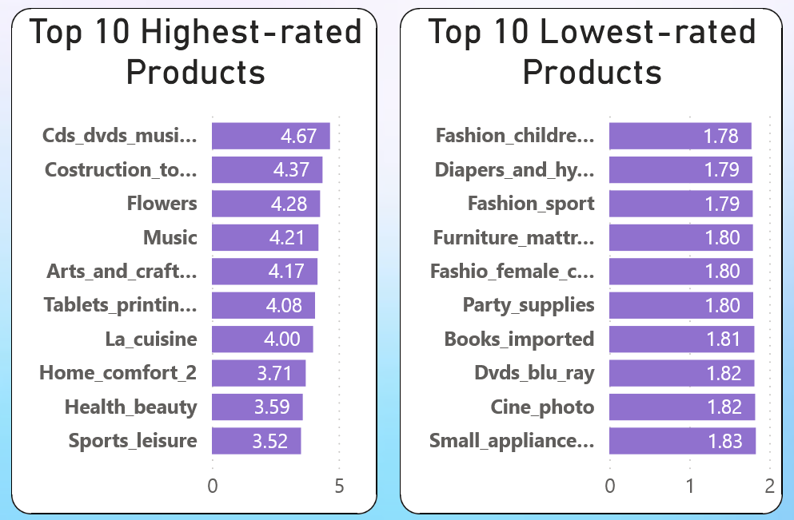

**Top 10 Highest-Rated Products:**

1. **Cds_dvds_musicals**: With an average review score of 4.67, products in this category enjoy exceptionally high customer satisfaction, suggesting a strong appeal to music and movie enthusiasts.
2. **Costruction_tools_tools**: At 4.37, construction tools receive positive reviews, indicating reliability and effectiveness in meeting customers' needs.
3. **Flowers**: Customers appreciate the quality and beauty of flowers, reflected in the high average rating of 4.28.
4. **Music**: Music-related products maintain a strong average rating of 4.21, indicating positive experiences and satisfaction among buyers.
5. **Arts_and_craftsmanship**: This category boasts an average review score of 4.17, suggesting high customer satisfaction with arts and crafts supplies.
6. **Tablets_printing_image**: Despite being slightly lower at 4.08, products related to tablets and printing maintain a positive reputation among buyers.
7. **La_cuisine**: Kitchenware and culinary products receive a respectable average rating of 4.00, indicating customer satisfaction with their functionality and quality.
8. **Home_comfort_2**: Although slightly lower at 3.71, products related to home comfort still garner positive feedback from buyers.
9. **Health_beauty**: Health and beauty products receive an average rating of 3.59, indicating moderate satisfaction among customers.
10. **Sports_leisure**: With an average rating of 3.52, products in this category receive lower but still generally positive feedback from buyers.

**Bottom 10 Lowest-Rated Products:**

1. **Fashion_childrens_clothes**: With an average rating of 1.78, children's clothing products receive the lowest ratings, suggesting dissatisfaction with their quality or design.
2. **Diapers_and_hygiene**: Similarly, products related to diapers and hygiene receive low ratings at 1.79, indicating potential issues with effectiveness or comfort.
3. **Fashion_sport**: Sporting apparel fares poorly with an average rating of 1.79, indicating dissatisfaction with the quality or fit of these products.
4. **Furniture_mattress_and_upholstery**: Furniture and upholstery products receive low ratings at 1.80, suggesting dissatisfaction with their durability or comfort.
5. **Fashion_female_clothing**: Women's clothing products also receive low ratings at 1.80, indicating potential issues with sizing, quality, or style.
6. **Party_supplies**: Party supplies receive an average rating of 1.80, suggesting dissatisfaction with their quality or suitability for events.
7. **Books_imported**: Imported books receive low ratings at 1.81, indicating dissatisfaction with their content, condition, or value.
8. **Dvds_blu_ray**: DVDs and Blu-rays receive an average rating of 1.82, suggesting dissatisfaction with their quality or condition.
9. **Cine_photo**: Products related to cinema and photography receive low ratings at 1.82, indicating potential issues with their performance or reliability.
10. **Small_appliances_home_oven_and_coffee**: Small appliances related to home, oven, and coffee receive low ratings at 1.83, suggesting dissatisfaction with their functionality or durability.

**Insights:**

* The top-rated products span various categories, including music, construction tools, and flowers, indicating a diverse range of customer preferences and interests.
* Lower-rated products are primarily concentrated in categories such as children's clothing, diapers, and furniture, suggesting areas where improvements in quality, design, or functionality may be needed.
* Understanding customer feedback and addressing pain points in low-rated categories can help businesses enhance product offerings, improve customer satisfaction, and drive loyalty and retention.

## **State-wise Sales Analysis:**

* Identify and visually represent states with high and low sales, providing a clear understanding of regional sales performance.

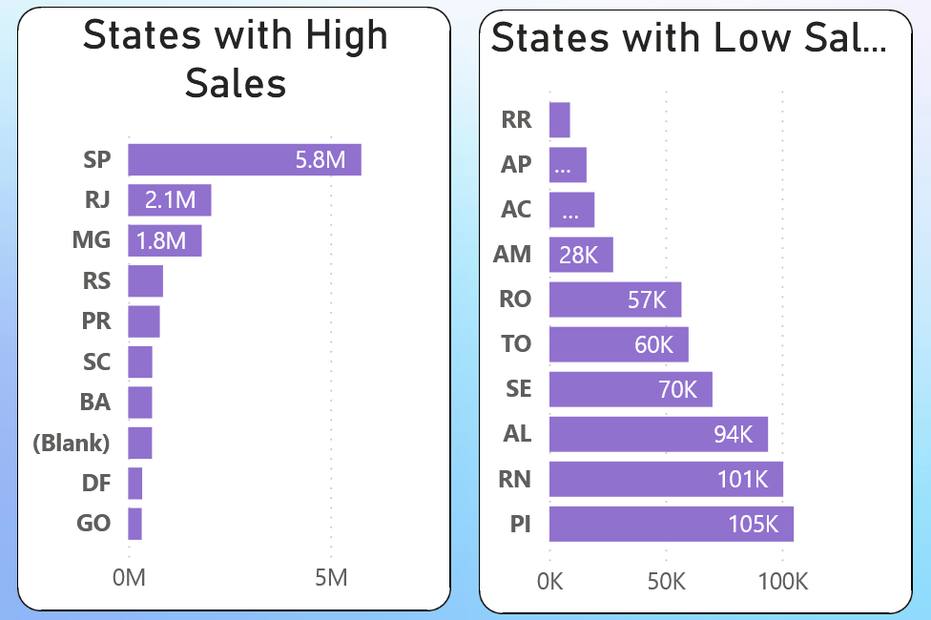

**High Sales States:**

1. **SP (São Paulo)**: Leads with sales totaling 5,768,355.09, reflecting robust economic activity and significant consumer spending.
2. **RJ (Rio de Janeiro)**: Follows closely with sales of 2,055,878.41, indicating strong market demand and purchasing power.
3. **MG (Minas Gerais)**: Contributes substantially with sales of 1,819,029.99, underscoring its importance as an economic hub.
4. **RS (Rio Grande do Sul)**: Reports sales of 861,054.35, indicative of stable economic conditions and a sizable consumer base.
5. **PR (Paraná)**: Records sales of 781,919.55, demonstrating a solid presence in the retail market and regional economic vitality.

**Insights from High Sales States:**

* São Paulo, Rio de Janeiro, and Minas Gerais exhibit strong economic activity and substantial consumer demand, making them prime markets for businesses.
* Understanding consumer preferences and market dynamics in these states is essential for strategic decision-making and market expansion initiatives.

**Low Sales States:**

1. **RR (Roraima)**: Reports the lowest sales at 9,039.52, reflecting its small population and limited economic development.
2. **AP (Amapá)**: Follows closely with sales of 16,141.81, indicating challenges in stimulating economic growth.
3. **AC (Acre)**: Records sales of 19,586.25, highlighting economic challenges in this remote region.
4. **AM (Amazonas)**: Reports modest sales of 27,596.18, indicating opportunities for infrastructure development and economic diversification.
5. **RO (Rondônia)**: Records sales of 56,975.70, reflecting its relatively small market size compared to larger states.

**Insights from Low Sales States:**

* States with low sales face challenges related to population size, geographic isolation, and economic development.
* Targeted marketing strategies and infrastructure investments are essential to stimulate economic growth and consumer spending in these regions.

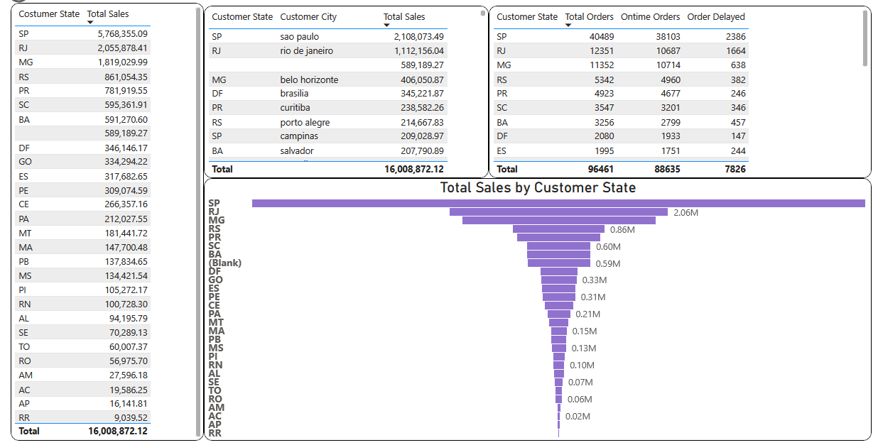

## **7. Seasonal Sales Patterns:**

* Investigate and visualize any seasonal patterns(Quarterly) or trends in sales data over the course of the year.

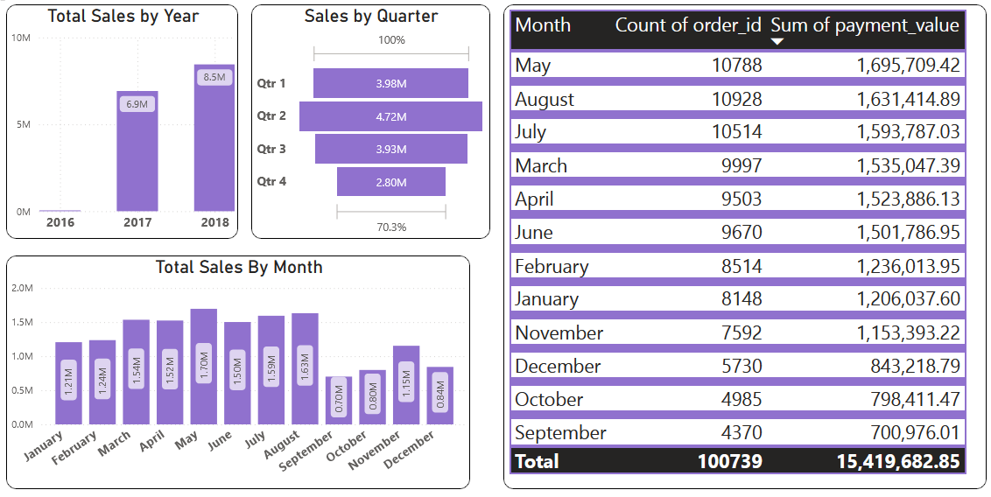

1. **Seasonal Variation**: There seems to be a seasonal pattern in both total orders and total sales. Generally, the summer months (May, June, July, August) exhibit higher sales compared to other months. This could be attributed to various factors such as warmer weather, summer vacations, or seasonal promotions.
2. **Peak Months**: May, August, and July stand out as the months with the highest total sales, which aligns with the observation of higher sales during the summer. These months might coincide with peak shopping seasons, holidays, or special events that drive consumer spending.
3. **Year-End Dip**: November and December show a decrease in total sales compared to the preceding months. This is a common trend observed in retail due to the holiday shopping season, where consumers tend to make purchases earlier in the year to prepare for festivities. However, it's worth noting that December still has higher sales compared to October and September, indicating a potential rebound in spending closer to the holiday season.
4. **Consistency in Spring**: March and April also show relatively high total sales, indicating consistent consumer spending during the spring months. This could be attributed to factors such as springtime promotions, clearance sales, or the anticipation of summer.
5. **Winter Months**: January and February have lower total sales compared to other months, which could be attributed to factors like post-holiday slowdown, colder weather keeping people indoors, or a focus on saving after holiday expenses.
6. **Overall Growth**: There is a general upward trend in total sales from September to May, with a peak in May, followed by a slight decline towards the end of the year. This suggests overall growth in sales over the course of the year, with fluctuations driven by seasonal factors and consumer behavior.
7. **Correlation with Total Orders**: The trends in total orders seem to closely mirror the trends in total sales, indicating a strong correlation between the number of orders and the total sales revenue generated each month.

## **Revenue Analysis:**

* Determine the total revenue generated by ShopNest Store  and analyze how it changes over time(Yearly). Represent this information through suitable visuals to highlight trends and patterns.

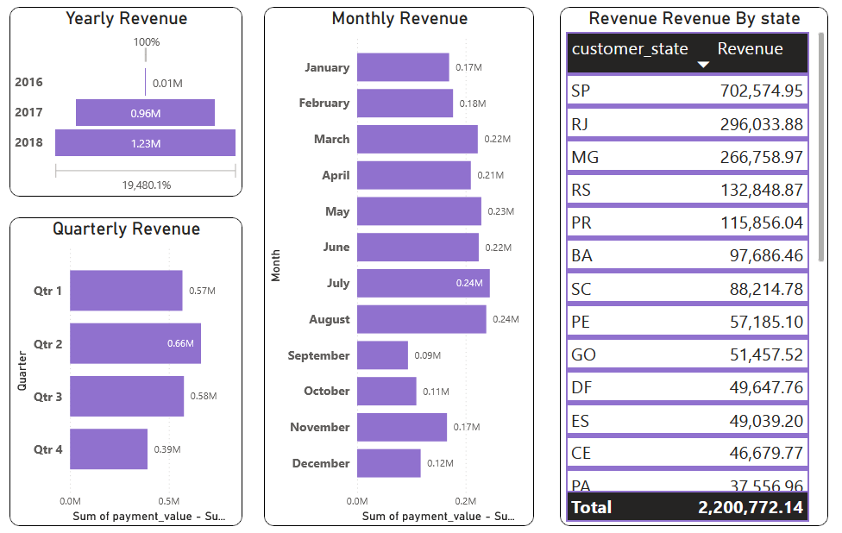

1. **Significant Growth**: There is a substantial increase in revenue from 2016 to 2017, indicating a period of rapid growth for the business. This growth could be attributed to various factors such as increased customer base, expanded product offerings, improved marketing strategies, or entering new markets.
2. **Steady Growth**: The trend continues with a further increase in revenue from 2017 to 2018, albeit at a slower rate compared to the previous year. This steady growth suggests that the business was able to maintain its momentum and capitalize on its previous success by sustaining customer loyalty, enhancing operational efficiency, or implementing new revenue-generating initiatives.
3. **Market Maturation**: The deceleration in revenue growth from 2017 to 2018 could also indicate a maturation of the market or increased competition. As the business grows larger and gains more market share, it becomes increasingly challenging to sustain the same high growth rates seen in earlier years.
4. **Economic Factors**: External economic factors such as changes in consumer spending habits, fluctuations in market conditions, or shifts in industry trends could also influence the growth trajectory of the business over time. Analyzing these external factors alongside revenue data can provide a more comprehensive understanding of the business environment.
5. **Future Outlook**: While the revenue growth rate may have slowed in recent years, the fact that the business continues to generate increasing revenue suggests a positive outlook. Businesses should continue to focus on innovation, customer satisfaction, and strategic planning to sustain growth and remain competitive in the market.

# Conclusion

In conclusion, the analysis of ShopNext Capstone Insights provides valuable insights across various aspects of the business, including sales performance, order fulfillment, payment methods, product ratings, regional sales dynamics, seasonal trends, and revenue growth over time.

Key takeaways include:

1. Identification of top-selling product categories, highlighting consumer preferences and market trends.
2. Analysis of delayed orders by category and month, emphasizing the importance of efficient logistics and proactive management.
3. Understanding of payment method preferences to optimize payment processing and enhance the customer experience.
4. Evaluation of product ratings to address areas for improvement and drive customer satisfaction.
5. Insights into regional sales performance to guide targeted marketing strategies and investment decisions.
6. Recognition of seasonal sales patterns to optimize inventory management and promotional efforts.
7. Examination of revenue growth over time, indicating a period of rapid expansion followed by sustained growth and market maturation.